Date: November 10, 2021
To: Weber County Board of County Commissioners

From: Ronna Tidwell
Community Development Department

Agenda Date: November 16, 2021

Subject: Request to Declare Parcel Number 24-003-0043 as Surplus Property

Attachments: A - Aerial View of Parcel
B - Recorder’s Plat
C – Market Value

_____________________________________________________________________________________

Summary:
A Weber County owned parcel of land, identified as Tax ID #24-003-0043, was acquired by the County through a tax sale process and deed executed in 2019. The parcel contains approximately .04 acres.
The County has been contacted by an adjacent property owner and was asked if the County would consider selling this property.
Weber County has no intended use for this property; therefore, it can be declared surplus and offered to an interested buyer. In order to convey real property, the County Commission must first take action to declare this parcel as surplus property.

Property Description:
24-003-0043

PART OF THE NORTH HALF OF SECTION 24, TOWNSHIP 5 NORTH, RANGE 3 WEST, SALT LAKE BASE & MERIDIAN, US SURVEY, DESCRIBED AS FOLLOWS: BEGINNING AT A POINT IN AN EXISTING FENCE LINE WHICH LIES NORTH 01D01'14" EAST 1108.86 FEET AND NORTH 88D58'46" WEST 485.80 FEET FROM A FOUND HOOPER CITY MONUMENT (95-6) IN THE INTERSECTION OF 5900 SOUTH STREET AND 5700 WEST STREET AND RUNNING THENCE NORTH 88D59'23" WEST 100.00 FEET, THENCE NORTH 01D12' EAST 18.00 FEET, THENCE SOUTH 88D59'23" EAST 100.00 FEET, THENCE SOUTH 01D01'12" WEST 18.00 FEET TO THE POINT OF BEGINNING. CONTAINING 1800.00 SQUARE FEET 0.041 ACRES.

Recommendation:
Declare Parcel 24-003-0043 as surplus property.

Attachment A
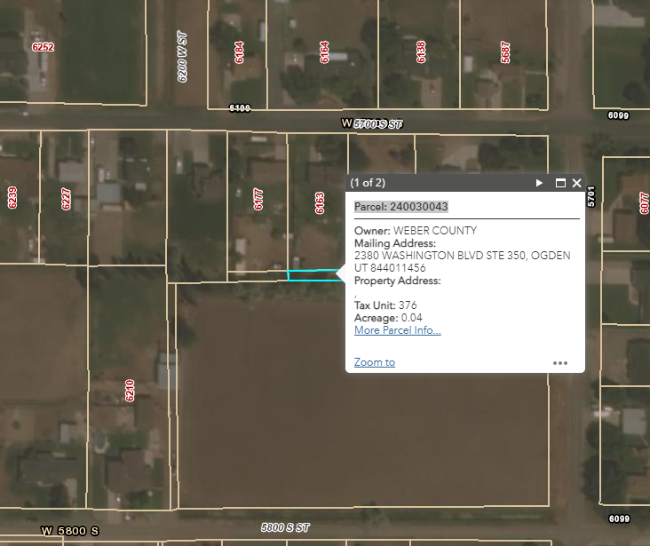

Attachment B

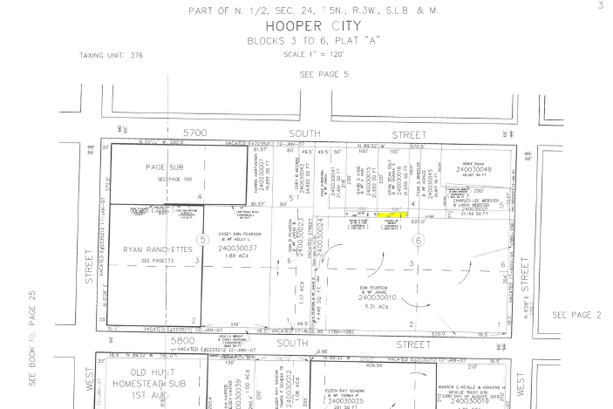

Attachment C
